I still haven’t decided what I want the general theme and setting to be, which is a small issue because that will greatly influence the items the game has but I’m not gonna worry about it too much. There are a few things I’m sure about:
- The game will be in general quite flashy. Within reason:
  - No filling the screen with damage numbers
  - No (or very limited) screen flashes (we want the cool kind of flashy not the blinding kind of flashy)
  - No 5 second attack/finisher cutscenes
    - Any cutscenes that are in the game (like potentially boss intro cutscenes) should be skippable
  - No ear rape from excessively layering sound effects
Think Bayonetta or maybe DMC? I dunno I’ve never played DMC
- The game will be fairly bloody
  - No blood explosions or blood on the camera though
- Some playable characters and enemies will be somewhat sexy
  - Not EVERY playable character should be a half naked conventionally attractive woman. But certainly a few of em ;3
  - Preference for stylish-sexy, not fanservice-sexy. Think something Bayonetta would wear. Or like Helltaker’s Judgement.
    - No cameltoe or nipple imprints
    - Avoid impossibly disproportionate sex appeal like Chun Li or Cordelia (Dead Estate)
    - Impractical armor ok
      - Including boob shaped breastplate
    - Short skirts & upskirt shots ok
    - Fighting in heels fine
  - Fully clothed or practical armor also fine! As long as it’s stylish.
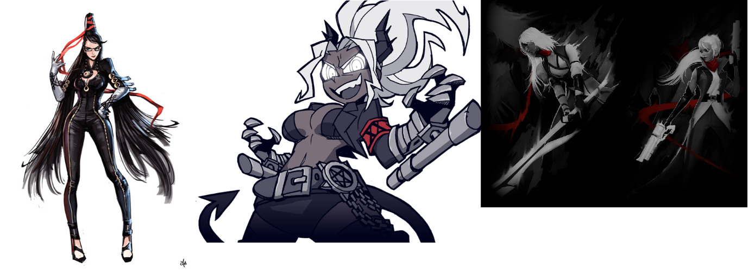
- The music should be metal!
  - Vocals even maybe?

